 **Indian Institute of Technology Patna**

**Dept. of Electrical Engineering**

IIT Patna Campus, Bihta – 801103

**Name -** Madan Kumar Jha

**Roll No. –** 2411EE23

**Project** - Classical PLL

**PFD/Charge Pump /C Cascade**

**Theory :**

In the context of PLL design, a charge pump is a circuit that sources or sinks charge for a controlled amount of time. Shown in Fig. 1(a) is a simple realization: if S1 is on, I1 charges C1, and if S2 is on, I2 discharges it. The controls are called Up and Down, respectively, as they determine whether the output voltage rises or falls. We assume I1 = I2 = Ip. Depicted in Fig. 7.29(b), the transistor-level implementation uses M1 and M2 as current sources and M3 and M4 as switches. Note that the gate control of M3 is called Up to emphasize that, when Up is high, this switch turns on. Since the switches are placed in series with the drains of the current sources, this topology is called a “drain-switched” CP.

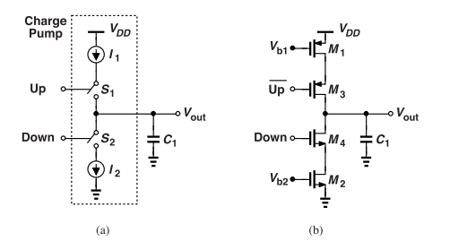

**Figure 1.** (a) Basic charge pump, and (b) transistor-level realization.

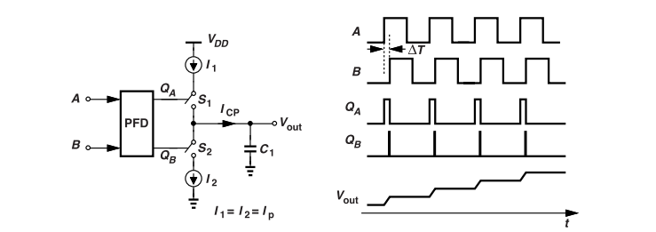

**Figure 2.** Cascade of PFD, charge pump, and capacitor along with the waveforms.

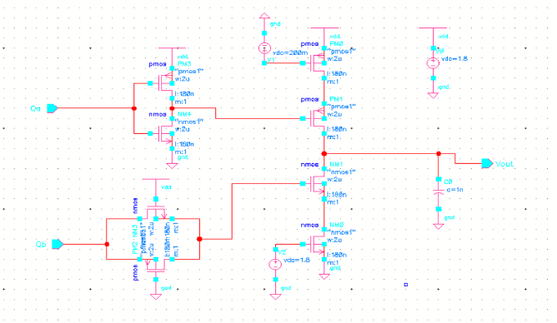

**Figure 3.** Charge Pump(CP) circuit diagram, drain-switched, & C cascade

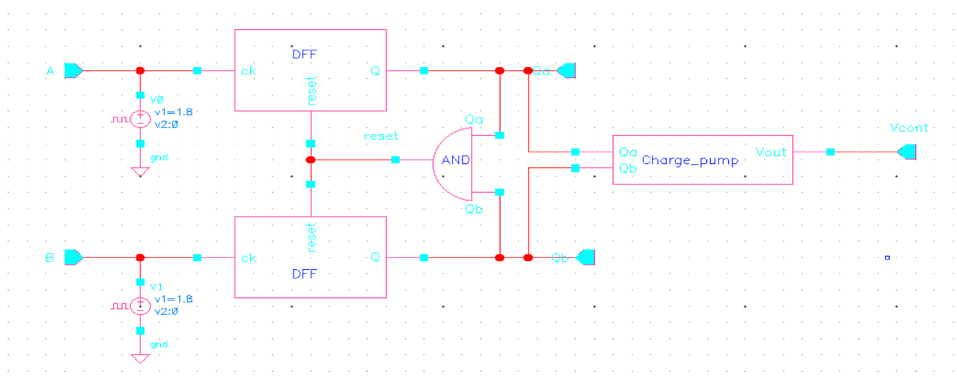

**Figure 4.** Charge Pump circuit diagram integrated with PFD.

**Result:**

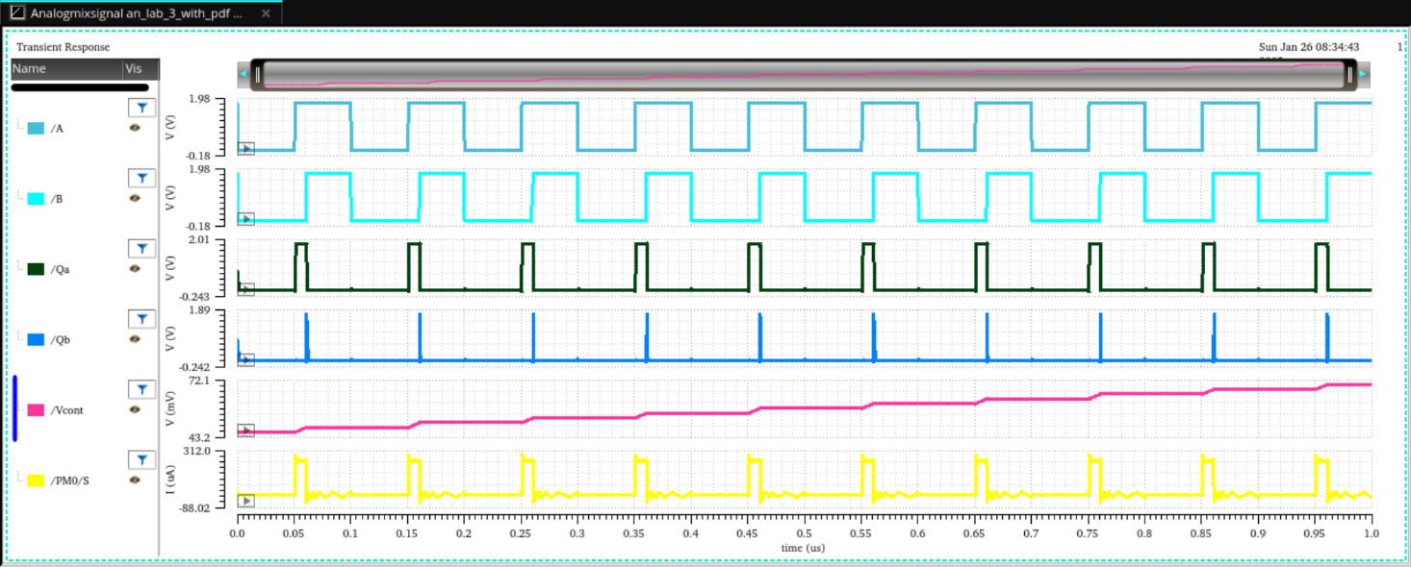

**Figure 5 (a):** Output waveform of case (i) Frequencies are equal but A leading B.

ωA - ωB = 0.628 μrad/s, ϕA=180°, ϕB= 216°

ϕB - ϕA = 36°





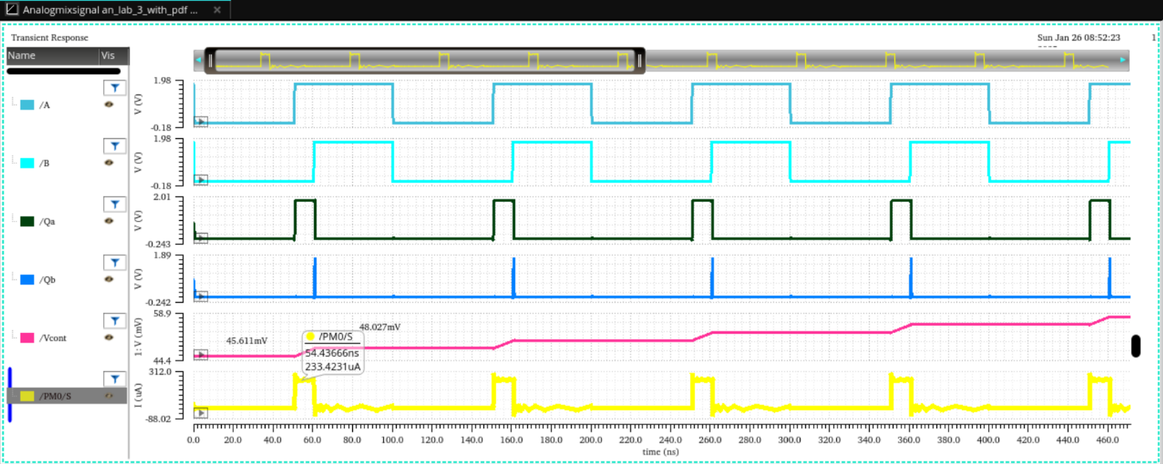**Figure 5 (b):** calculation of voltage rise from plot of fig 5(a)

Since, Δv = (1/c) ⋅ (i ⋅ Δt)

Δv =(1/1nf) ⋅(233.4231μA⋅10ns) =2.334mV

From plot Δv = (48.027-45.611)mV=2.416 mV which is approximately equal.



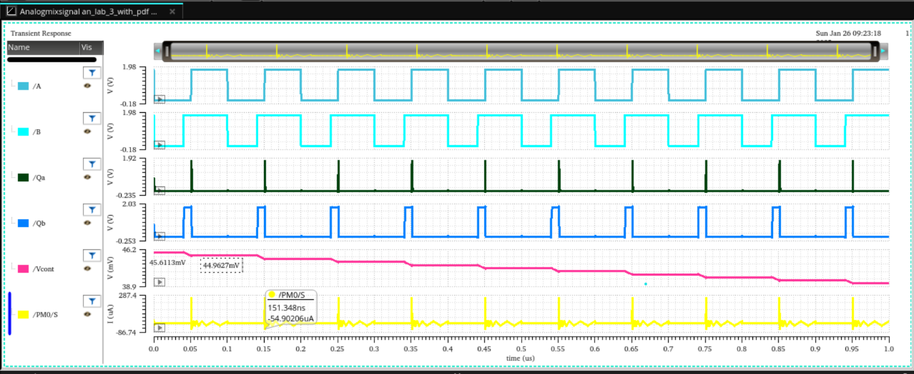

**Figure 6 :** Output waveform of case (ii) Frequencies are equal but A lagging B.

ωA - ωB = 0.628 μrad/s, ϕA=180°, ϕB= 144°

ϕA - ϕB = 36°

Since, Δv = (1/c) ⋅ (i ⋅ Δt)

Δv =(1/1nf) ⋅(-54.90206μA⋅10ns) =0.549mV

From plot Δv = (45.6113-44.9627)mV=0.6486 mV which is approximately equal.

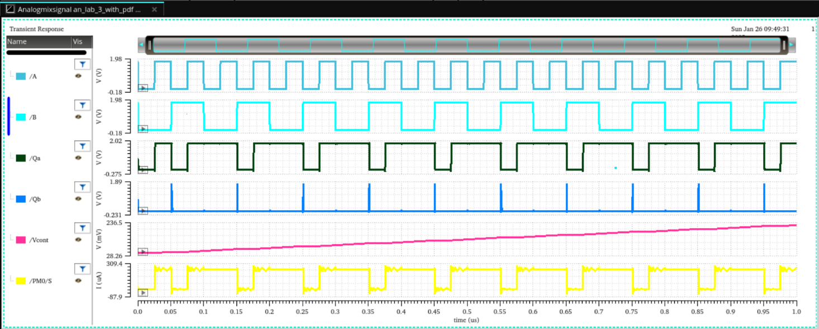

**Figure 7:** Output waveform of case (iii) ωa > ωb.

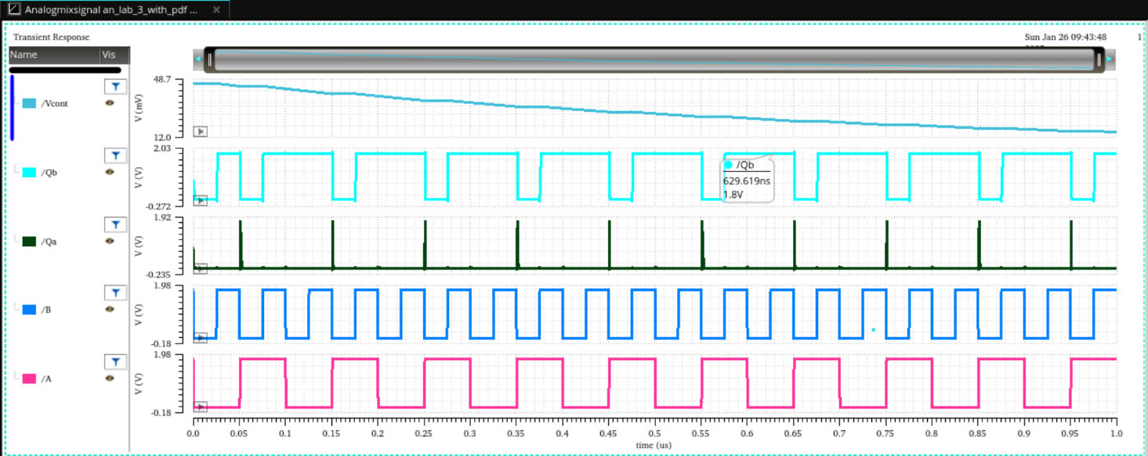

**Figure 8:** Output waveform of case (iii) ωa > ωb.